Theoretical foundations for topological insulators and superconductors:

**What is the ultimate goal of this discussion?**

∙ To discuss topological insulators in terms of the Hamiltonian of electrons in a 1D solid lattice and to show that there exits two states on the boundary of this lattice (edges) where under certain conditions no energy is required to place electrons there. We call these edge states Majorana operators and the lack of energy gap to place electrons here means that superconducting can occur on the edge. (?)

∙

-------------------------------------------------------------------------------------------------------------------------

**How do we define a topological insulator?**

∙ Insulator = material where all e- bound speci places

∙ Topological insulator = sys where e- in centre material stuck in place but e- near edges free to move

=> Insulator in bulk of material but conductor on the surface

**How does a topological insulator occur?**

∙ Hall effect = e- in mag field move in circles (what physics is behind the circular motion?) → treats e- as particles (in what type of material?)

∙ Quantum hall effect = hall effect that treats e- as new state w/ wavelike properties → so orbits of e- must be discrete, imagine standing wave that must loop back on itself → can only increase orbit when E satisfies this standing wave property (what wavelike properties are important?)

∙ Surface states on edges material can carry current as orbits bounce into edge of material → creates conductance, in bulk e- bound in orbits

=> Magnetic field through material (what?) creates a quantum hall effect which cause e- in bulk bound in circular orbits, e- near edge that interfere w/ edge so conduct

**Can we create a topological insulator without a magnetic field?**

∙ If imagine simply removed B and same process occurred → violates time reversal symmetry as direction orbit is different depending on if we watch video of process forward or backward

∙ Expect real sys to have time reversal symmetry → real sys should have e- spin correlated to dir motion, that way flip time (reasoning behind choosing e- spin to be correlated with dir motion?) → flip spin so everything looks the same

=> If we assume e- spin is correlated with the direction of current flow on the edge state we can imagine a material with a Quantum Hall Effect and time reversal symmetry → in other words topological insulator that doesn’t require B

**How do we describe conductance in the language of band theory of solids? This isn’t all correct!!**

∙ Materials have conductance band where e- of this energy (or greater) have sufficient E to escape atomic lattice and participate in conduction

∙ From Pauli exclusion principle e- cannot exist in identical energy states. Fermi level is surface of sea of e- packing into the lowest available E states at absolute zero → energy gap between Fermi level and conduction band is energy barrier to conduction = BAND GAP

∙ In semi-conductors thermal energy is enough to get portion of e- to cross band gap and participate in conduction

=> To conduct, e- must have sufficient energy to break free lattice → the min energy level and above = CONDUCTION BAND. Difference between Fermi level and conduction band= BAND GAP, E barrier to conduction → conduction occurs when e- have sufficient E to be in the conduction band

**What are bands and how are valence bands, conduction bands and Fermi level related to the conduction of the material?**

∙ e- don’t have discrete energies as in case free atoms but available E states form bands → e- can only exist in these bands

∙ Insulators have large band gap between valence band (energy of the valence e-) and conduction band (E necessary for conduction) → no E states that can be occupied in this gap → CONDUCTION REQUIRES e- TO BRIDE THIS GAP

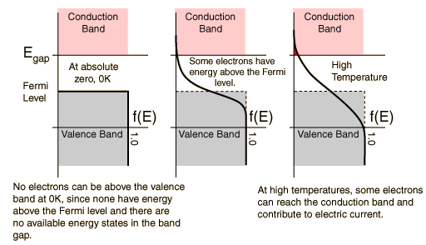∙ Fermi function tells us prob that available e- state will be occupied at certain temp → at temps above 0K tells us fraction e- that can exist above Fermi level → see diag

∙ Although function has value in gap, no e- present → pop. e- depends product Fermi function and desity E states

=> bands represent the energies that e- in a solid can take. Valence band= energies of valence e-, conduction band= energies of e- that can participate in conduction. Band gap= difference between these two bands where E states are absent. Position Fermi level in band gap (+ temp) determines fraction of e- that have prob. of conducting (i.e. existing above Fermi level in conduction band)

**What is a Brillouin Zone, what is the importance in our discussion?**

<http://www.doitpoms.ac.uk/tlplib/brillouin_zones/index.php>

∙ Seems to be a mathematical tool to refer to distinct regions in the lattice of atoms that form a solid → useful in understanding the electronic and thermal properties of crystalline solids (?)

**What are Bloch waves, how are they important to our discussion?**

∙ Wavefunction used to describe e- in (periodically-repeating environment) lattice. Bloch's theorem says E Eigenstates for e- in crystal can be written as Bloch waves → determines allowed wavefunctions for e- in solid, so determines BAND STRUCTURE

**How do we describe fermions in a 1D system?**

∙ Each fermion site describe by pair annihilation and creation operators, cj c†j. → |1> = cj |0>

∙ μ = chemical potential, E you need to pay to put fermion in state